美国政府在有意隐瞒新冠病毒疫情吗？

原创 罗马主义 [灼识新维度](javascript:void(0);)

**灼识新维度**

微信号 gh_4c12eeda5979

功能介绍 不一样的视角，不一样维度，带来全新观点，全新认知升级

2020-02-24[原文](https://mp.weixin.qq.com/s/PfL_33otKbkOFfWoU1xOuA)

收录于话题

#时政评论

13个

 戳蓝字**“灼识新维度”**关注我们哦！

昨天我在查看美国的官方媒体《美国之音》的时候，突然发现美国疾控中心在2月22日发布了一篇奇怪的声明，说是新型冠状病毒，有“可能”在美国流行，美国也有“可能”，有朝一日，会采取和中国一样的措施，让学校停课，企业停工以控制疫情传播，这让人很是诧异。

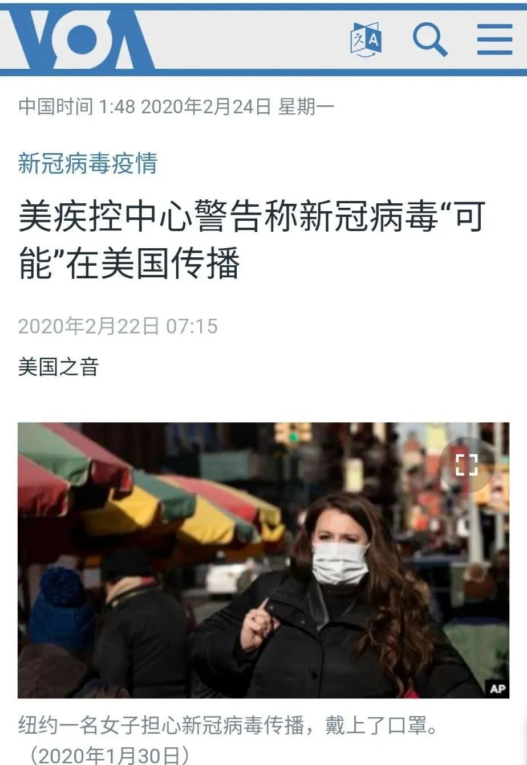

为什么我说这让人很是诧异呢？因为美国疾控中心在文章的后面宣布，美国截止2月21日，只有34例感染者，其中21名是撤侨，没有发生社区传播。

按说这么少的人，都在掌控之中，完全不会对美国社会构成威胁，美国疾控中心应该不至于大惊小怪，发出这样一个警示吧？

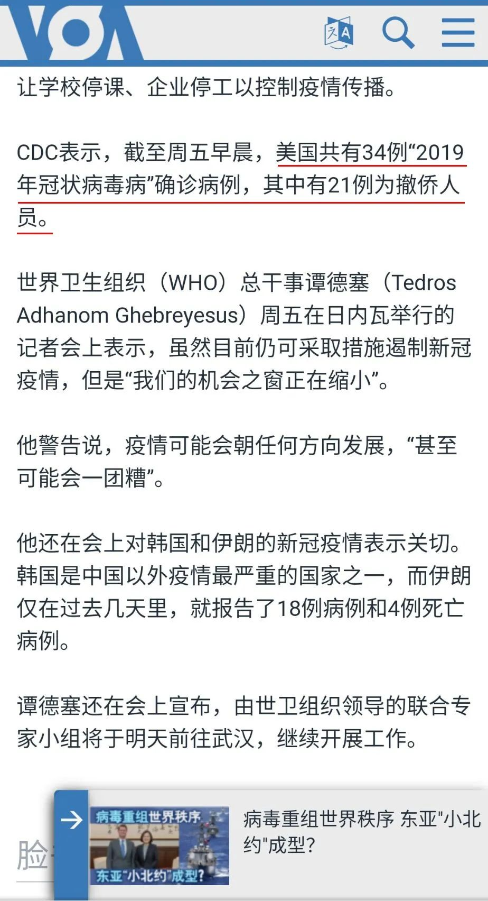

可是接下来，我又在美国之音上，发现了另外一个让人震惊的消息，美国一名联邦法官在2月21日发出临时限制令，不准联邦政府把50名新冠病毒感染者送到加州南部城市科斯塔·梅沙（Costa Mesa）的一个州政府设施进行隔离。

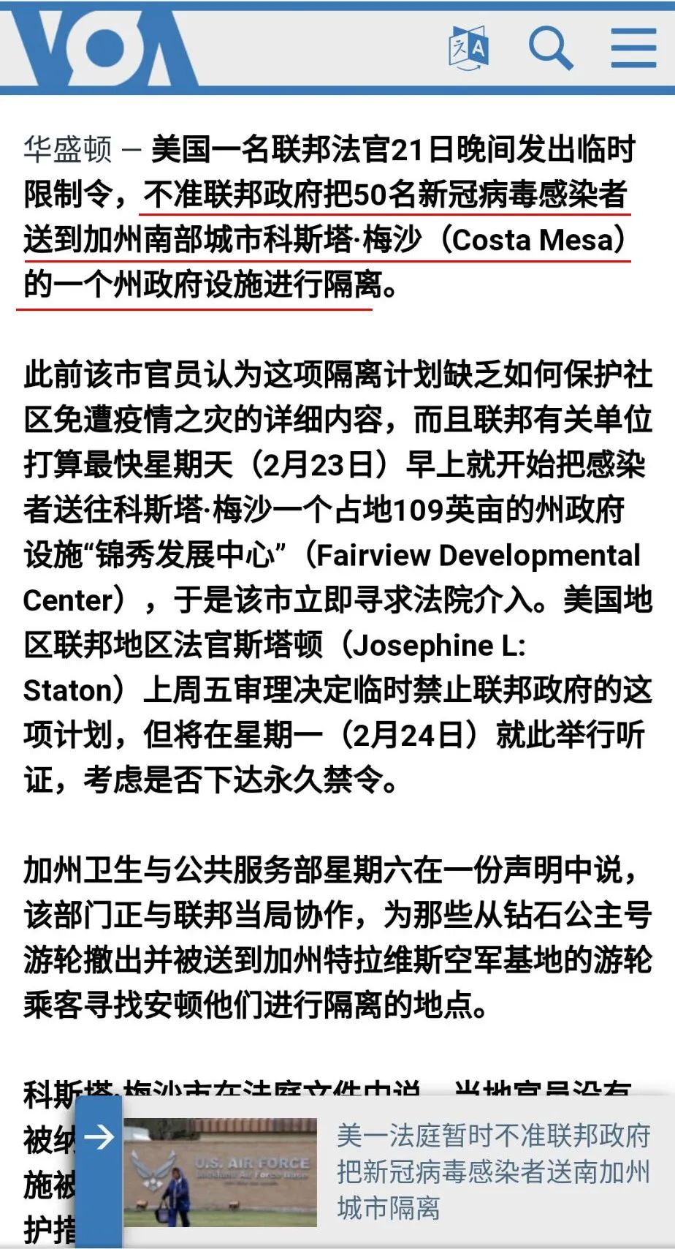

这顿时就让我震惊了，因为前面美国疾控中心才说过，截止二月二十一日，美国只有34名感染者，其中21名是撤侨，怎么突然又冒出来50名感染者，而且要被送去隔离？

请大家注意，据美国之音的报道，法官的判决是2月21号晚上发出的，那么这个案件肯定不是在2月21号才递上去的，所以换句话说，这些病患早就存在，但是美国没有公布。

我不知道是不是美国官方发现了这个自相矛盾的问题，于是加州卫生与公共服务部在2月22日，星期六发表的一份声明中说，该部门正与联邦当局协作，为那些从钻石公主号游轮上撤出，并被送到加州特拉维斯空军基地的游轮乘客，寻找安顿他们进行隔离的地点。

注意，这个声明是发生在判决之后，2月22号，在此之前从没有人公布过，这50名感染者的存在，显然有人意识到，这可能漏了马脚，于是急忙补救。

但是问题是，这又产生了更多的疑问，文章中说联邦有关单位打算最快在星期天，也就是2月23日早上，就开始把感染者送往科斯塔·梅沙一个占地109英亩的州政府设施“锦秀发展中心”（Fairview Developmental Center）。

从这个要求来看，这些患者显然已经在美国了，可是当时美国疾控中心公布的本土病例只有34个，其中21个是撤侨，那么这50个感染者，又是从那钻出来的呢？

请注意，声明原文里说过，这个计划是为已经到美国加州特拉维斯空军基地的撤侨找地方，所以肯定要计入本土病例，既然撤侨只有21个病例，这是国际上都知道的，所以这50个人到底是不是全都是撤侨，也让人疑惑。

由于这些资料全部来自《美国之音》，美国的官方媒体，面对这两个截然不同的数据，不能不让我弱弱的想问一句，美国政府是不是在有意的隐瞒疫情？

因为截止2月21日，美国疾控中心宣布的无论是国内的感染者，还是从钻石公主号上的美国感染者18人，都和这50个人对不上号，他们的下落完全没有交待。

请再次注意一下，这50个感染者在2月21日之前就被发现，但是为什么没有出现在美国疾控中心统计数据中？他们到底现在在那里？是一个什么情况？美国政府需要一个交待。

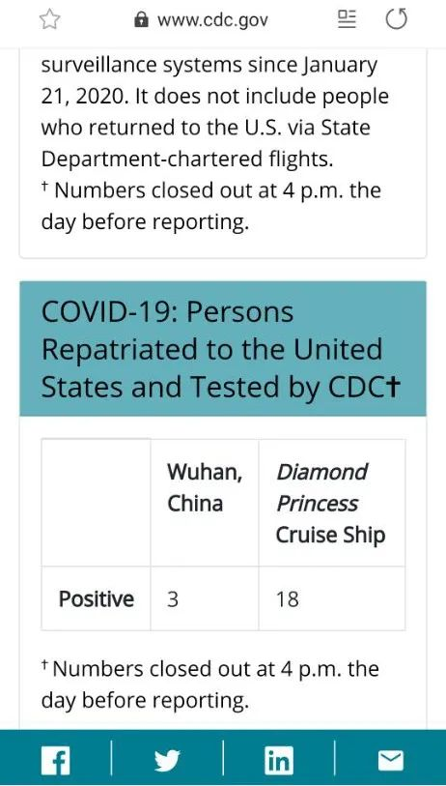

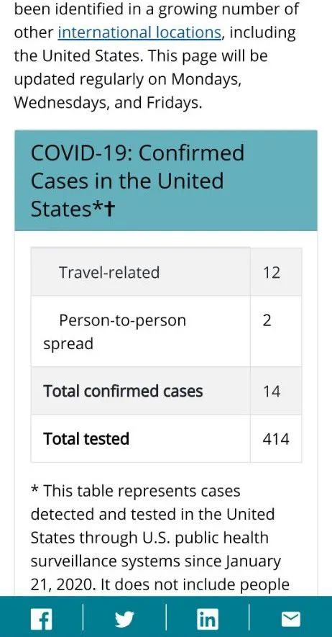

如果再结合美国疾控中心在2月22日发表的声明，你会发现，这似乎都是为即将到来的某件事，在做舆论准备，你再仔细的体会一下文中的这些说法，似乎全是一些暗示，让人有一种不详的预感。

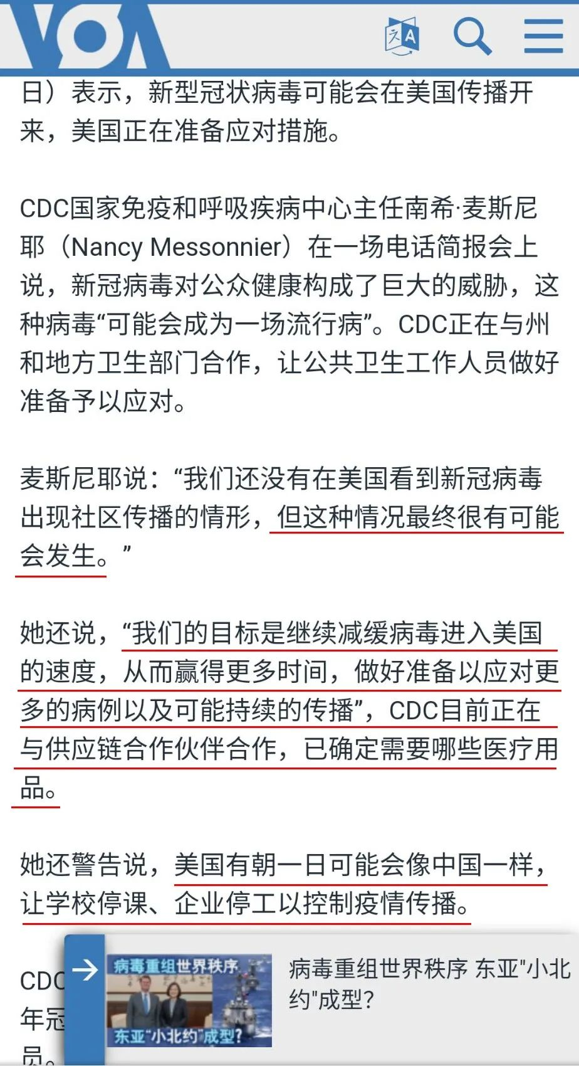

除了美国之音里，这两个让人困惑的报道之外，最近YouTube上出现了一个美国的爆料人，声称美国有一千多例患者，被疾控中心故意隐瞒，在一家叫做《今日澳洲》的华文媒体上，声称美国的2600万流感患者，14,000名死亡者中，有很多可能是新冠肺炎，被误诊为流感。

另外还有一些报道声称，在很多国家里发生的新型冠状病毒肺炎，并没有和中国人的接触史，找不到疾病的源头，也让人非常困惑。

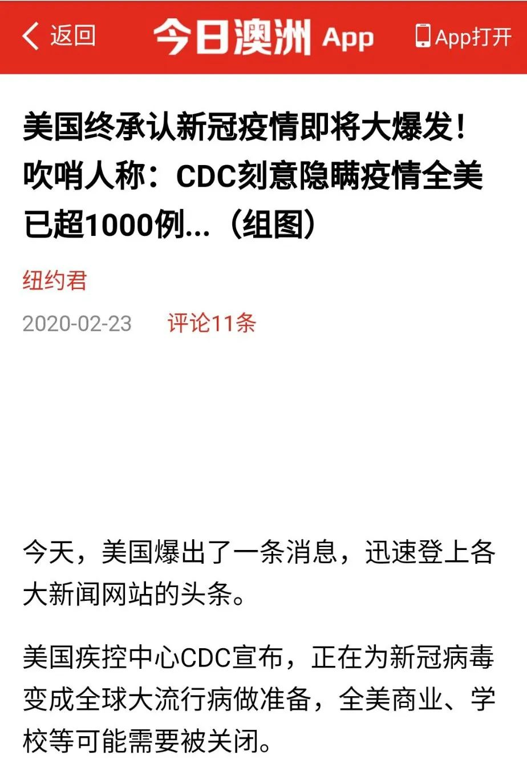

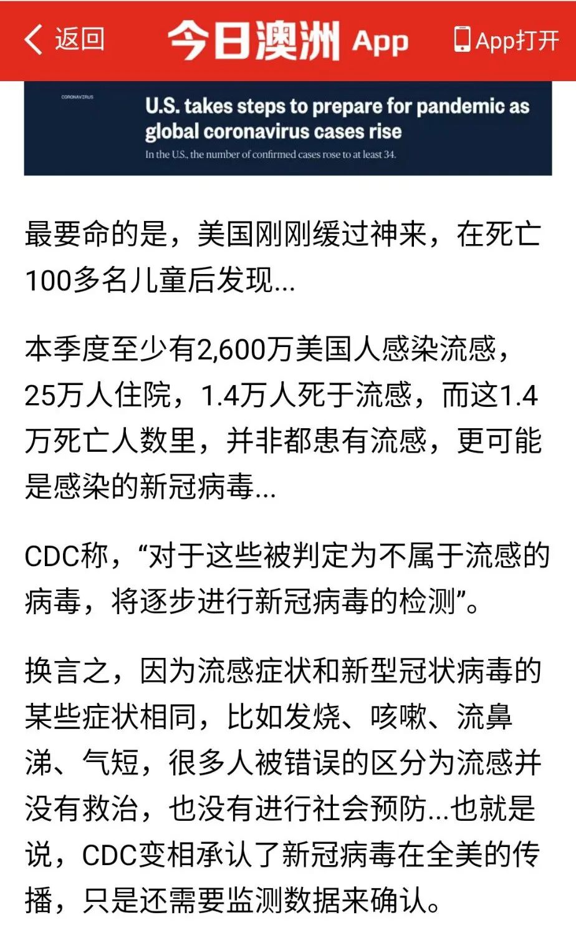

不过作为一个写史的公众号，我很注意材料来源的权威性，所以除了官方的美国之音，以及美国疾控中心的官网数据外，这些非权威资料一般不被作为证据，只是提供给大家参考，和本文的观点无关。

当然，我非常希望这是美国政府搞的一个乌龙事件，千万不要是某个可怕的冰山一角，更不要让很多“阴谋论”不幸言中，否则那将会是一场灾难。

因为如果新冠肺炎真的会在美国流行，那将是对全球经济的又一个沉重的打击，在全球化的今天，没有人可以独善其身，更没有人有资格幸灾乐祸。

而且我也很担心，如果真的发生了意外，美国政府到底有没有能力，像中国政府一样，动员全社会来处理疫情。毕竟美国的政体和中国的政体相差很大，有些中国能做到的事情，美国是做不到的，所以最好这只是美国之音搞错了，否则将是一场彻头彻尾的灾难。

除了向大家报告我这个无意中的发现，另外我也要给大家解释一下，最近没有更新的原因，是因为春节期间我出国旅游，恰逢疫情爆发，遇到了隔离，被困在了国外，暂时无法回国。

由于当时只是计划了一个一周的短期旅游，所以所有的清史资料都留在国内，没有下图中的这些书，我暂时没法写作，只有回来后才能继续更新，而且我出国前换了手机，登不上公众号后台，看不见留言，无法回复，请大家谅解。

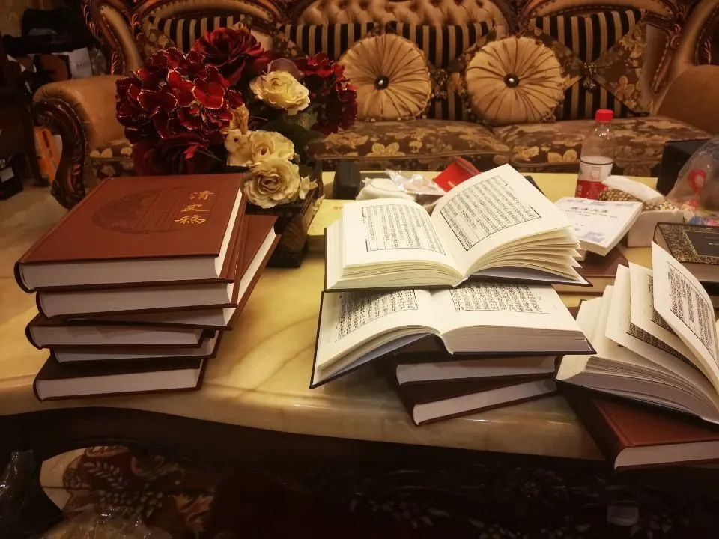

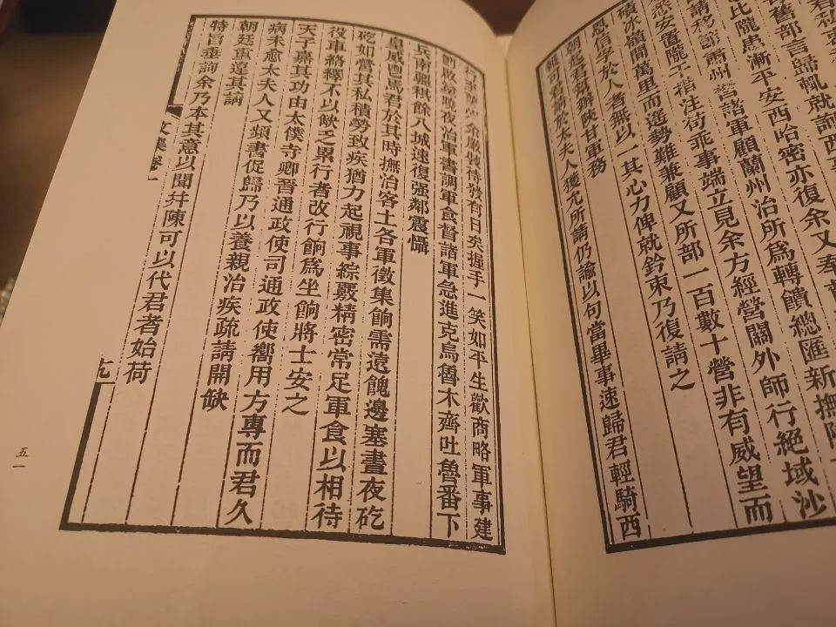

**在这里我祝大家身体健康，万事如意，并祈祷疫情早日结束，让社会尽快重回正轨，祝所有的人都能平平安安，渡过这次难关，再次感谢大家长期以来的关注，谢谢。**

**以防失联，请大家关注备用号，谢谢大家长期以来的支持。**



灼识熔接机



以防失联，请长按此二维码识别关注。

备用号



§§

**精彩文章**

1[、为什么说《新疆的若干历史问题》白皮书的发表，证明了《晚清沧海事》下卷的历史判断是正确的？](http://mp.weixin.qq.com/s?__biz=MzU0Mjc2OTkzNQ==&mid=2247485214&idx=1&sn=4e2d58896010c0ab57b9bf431b70a0c4&chksm=fb14d17ecc635868803a3b7a5dd899ccc2368119094bb6c7bb709383c3b37318122dbf5d9856&scene=21#wechat_redirect)

[2、到底谁在忽悠我们？？](http://mp.weixin.qq.com/s?__biz=MzU0Mjc2OTkzNQ==&mid=2247485314&idx=1&sn=d6d24169d1331e341cba702f147380f6&chksm=fb14d1e2cc6358f48b9fc11812adcdf38f72532dfb925f6bddb71b13a7ffea882b6c71b864fe&scene=21#wechat_redirect)

[3、我们到底需不需要一个伟大的祖国？](http://mp.weixin.qq.com/s?__biz=MzU0Mjc2OTkzNQ==&mid=2247485358&idx=1&sn=fda07ee0134ffc76228c9c7643792634&chksm=fb14d1cecc6358d811560baab9f7fcfccfcc464b5509cd634da4df7030e95e4216c53986bc1f&scene=21#wechat_redirect)

[4、英国BBC镜头之下的美国，到底有多出乎我们的意料？](http://mp.weixin.qq.com/s?__biz=MzU0Mjc2OTkzNQ==&mid=2247485464&idx=1&sn=50372e5f63f41332a2a1fb1d8349325c&chksm=fb14de78cc63576e944b33d9fbd248a1c7b4f19a4ac1f1ee64a5e280df32abedce183e52cf90&scene=21#wechat_redirect)

**晚清沧海事（上卷）**

[晚清沧海事 1：序，一个流传已久的谎言](http://mp.weixin.qq.com/s?__biz=MzU0Mjc2OTkzNQ==&mid=2247483846&idx=1&sn=a98e6f2c09cacfc871e85017465d8afb&chksm=fb14d7a6cc635eb012436f3d46bf52071da509f44997a0b8b76d70b0a7d77b063b475ee606d6&scene=21#wechat_redirect)

[晚清沧海事 2：各种洋鬼子们](http://mp.weixin.qq.com/s?__biz=MzU0Mjc2OTkzNQ==&mid=2247483858&idx=1&sn=7ef1461b68c8a988c43de0e06a72dc74&chksm=fb14d7b2cc635ea4bdf750d2103adca9910c559c13cc6007fc97e4fc03b888169e4f89fc943e&scene=21#wechat_redirect)

[晚清沧海事 3：耶和华和他的儿子们](http://mp.weixin.qq.com/s?__biz=MzU0Mjc2OTkzNQ==&mid=2247483872&idx=1&sn=d3f38e6522ba991a181bc8c93effbcbe&chksm=fb14d780cc635e968645a2b88f1f4fb7bf20aa617ca7c52c80440a7679a8a96bcf64060147ae&scene=21#wechat_redirect)

[晚清沧海事 4（上）：心在麦加的中国人](http://mp.weixin.qq.com/s?__biz=MzU0Mjc2OTkzNQ==&mid=2247483957&idx=1&sn=d6b972ab195e6fe6c73468bd9944b72c&chksm=fb14d455cc635d43583405413beb0f395a3e649731402835579d4af6686f71c8bd00d63ba9df&scene=21#wechat_redirect)

[晚清沧海事 4（下）：前进路上的绊脚石](http://mp.weixin.qq.com/s?__biz=MzU0Mjc2OTkzNQ==&mid=2247483999&idx=1&sn=62320ac5bab8706509ff732b33ea9b14&chksm=fb14d43fcc635d296c8e950bf061b5c942a64bdf664ffb3d3a3a880884e0df04d33c0c9595a7&scene=21#wechat_redirect)

[晚清沧海事（漫画彩蛋版一）](http://mp.weixin.qq.com/s?__biz=MzU0Mjc2OTkzNQ==&mid=2247484037&idx=1&sn=3c77c0273914f7c24dcca5634e31fef7&chksm=fb14d4e5cc635df3d01aeea65c4ac6318ed535074f8d78d9bef622e56df3d7cb932a429a1ec4&scene=21#wechat_redirect)

[晚清沧海事 5（上）：爱国者](http://mp.weixin.qq.com/s?__biz=MzU0Mjc2OTkzNQ==&mid=2247484067&idx=1&sn=a0d87b6ec1bff902df8efa0523fd158b&chksm=fb14d4c3cc635dd5f6301b9daa96861117110659b06ef4568569cdb26c9705e9a0828140e50f&scene=21#wechat_redirect)

[晚清沧海事 5（下）：那些年，那些事，那些被掩盖的真相！](http://mp.weixin.qq.com/s?__biz=MzU0Mjc2OTkzNQ==&mid=2247484088&idx=1&sn=50c2f39030d03816d81f18feb78605f3&chksm=fb14d4d8cc635dce9f4b64e9e5cad31136456d1e398d6515ca753014641b68f149606f59b9f1&scene=21#wechat_redirect)

[晚清沧海事 6：潜伏，一个大阴谋是怎样炼成的？](http://mp.weixin.qq.com/s?__biz=MzU0Mjc2OTkzNQ==&mid=2247484097&idx=1&sn=919edde52aad692cdd9e4a953e0fdd24&chksm=fb14d4a1cc635db773d10a158657e9fe550721726c4ddce607f2d1c5a8b62be03f164f6c859e&scene=21#wechat_redirect)

[晚清沧海事 7：一个改变历史走向的抉择](http://mp.weixin.qq.com/s?__biz=MzU0Mjc2OTkzNQ==&mid=2247484108&idx=1&sn=8352854cf9c38b927da105c8e41b50a0&chksm=fb14d4accc635dba1e06975e3d88869b081270c17e7915f70ef083dfffe903c869a3f69f0562&scene=21#wechat_redirect)

[晚清沧海事 8：最后的满洲武士](http://mp.weixin.qq.com/s?__biz=MzU0Mjc2OTkzNQ==&mid=2247484122&idx=1&sn=9c0b266e12b2d8b070fda1bf4622bb20&chksm=fb14d4bacc635dac631ef801273e128dea9161862c4071756a386b3afd2387eb2f2f98c1f56d&scene=21#wechat_redirect)

[晚清沧海事 9：富贵险中求，不拿命来换！](http://mp.weixin.qq.com/s?__biz=MzU0Mjc2OTkzNQ==&mid=2247484132&idx=1&sn=19ede71685995c6ef1372ebe5e611de0&chksm=fb14d484cc635d920d764449b0467c849f9fbd61b8982befe5cd011f58439c8cb0ad3bdb0f67&scene=21#wechat_redirect)

[晚清沧海事 10：山雨欲来风满楼](http://mp.weixin.qq.com/s?__biz=MzU0Mjc2OTkzNQ==&mid=2247484137&idx=1&sn=81cacdc5539096fae21f0a0f0847eecc&chksm=fb14d489cc635d9f7c31906852befe49d0fcb4a9080bede330a8e91de9f088f6d59783571c5c&scene=21#wechat_redirect)

[晚清沧海事 11：西北大叛乱](http://mp.weixin.qq.com/s?__biz=MzU0Mjc2OTkzNQ==&mid=2247485523&idx=1&sn=59bf5768408f5d69190e6a57b9a60489&chksm=fb14de33cc635725d5802a758a73efc7a90aff6631126d69c0a8bd352d2392781333c2ac3144&scene=21#wechat_redirect)

[晚清沧海事 12：大英雄](http://mp.weixin.qq.com/s?__biz=MzU0Mjc2OTkzNQ==&mid=2247484157&idx=1&sn=b250eb3ccf8990686d9f3332fe1979be&chksm=fb14d49dcc635d8b7af012dc1043eaa809b5b3ce4aa14cae1ceadcc5d0c4ed0c64f7a989fbd6&scene=21#wechat_redirect)

[晚清沧海事 13：长壕之战](http://mp.weixin.qq.com/s?__biz=MzU0Mjc2OTkzNQ==&mid=2247484167&idx=1&sn=7308bbd0f879b2d4a3c96bc961c6aef4&chksm=fb14d567cc635c718e59632529f5f156121d031ae6b8dec02b9810061c03ca414cdd455b7acd&scene=21#wechat_redirect)

[晚清沧海事 14：交口之战](http://mp.weixin.qq.com/s?__biz=MzU0Mjc2OTkzNQ==&mid=2247484175&idx=1&sn=aa4c0824898616289decf11a976112f2&chksm=fb14d56fcc635c791b97a3c2bb5f05578b4e2aae4136f53f915275c3744b83b63943e5c54c52&scene=21#wechat_redirect)

[晚清沧海事 15：甘宁叛乱](http://mp.weixin.qq.com/s?__biz=MzU0Mjc2OTkzNQ==&mid=2247484180&idx=1&sn=d4387287e3fdd5e2cb3bb21aa3639ea4&chksm=fb14d574cc635c62d7bf4a72d27d480ae3c61b5cde7b5927337c1e611bc4d9df04087da7dbe3&scene=21#wechat_redirect)

[晚清沧海事 16：一个高干子弟，是怎样搞砸西北平叛的？！](http://mp.weixin.qq.com/s?__biz=MzU0Mjc2OTkzNQ==&mid=2247484185&idx=1&sn=c48eb724da9a1c027548a1f6e0ac81e2&chksm=fb14d579cc635c6f06c0e902d971ef8686934b9937fba963d87635c6fe4b0a0758168b213cc6&scene=21#wechat_redirect)

[晚清沧海事 17：西北崩盘](http://mp.weixin.qq.com/s?__biz=MzU0Mjc2OTkzNQ==&mid=2247484194&idx=1&sn=0899f9db1c3186a47f482ba29a0b603a&chksm=fb14d542cc635c54dee67d90dc72eba0e3da73bee956e27d37fc7b51fa522a1c25824b398c2b&scene=21#wechat_redirect)

[晚清沧海事 18：四面楚歌（上）](http://mp.weixin.qq.com/s?__biz=MzU0Mjc2OTkzNQ==&mid=2247484204&idx=1&sn=fcb81bc49ace438e03b4853cf7fb4a56&chksm=fb14d54ccc635c5a4fe0b3caf877f2715351cc657423ca826b14bd7574a4260f8a2c638a01c2&scene=21#wechat_redirect)

[晚清沧海事 19：四面楚歌（下）](http://mp.weixin.qq.com/s?__biz=MzU0Mjc2OTkzNQ==&mid=2247484215&idx=1&sn=7d7cdcf957f2ff06b47f91e999d19cb5&chksm=fb14d557cc635c41083cc77b3465df9764a6ad6d6bb07d9182b36da0a5e2a25e9345930763e3&scene=21#wechat_redirect)

[晚清沧海事 20：至暗时刻](http://mp.weixin.qq.com/s?__biz=MzU0Mjc2OTkzNQ==&mid=2247484223&idx=1&sn=c3697701833bee7ca894dc5c156f7be0&chksm=fb14d55fcc635c49528b66d3b9cf5fcdfde3a27b7db83d981f59b37c27c4fc9d4d5a3ff049fb&scene=21#wechat_redirect)

[晚清沧海事 21：乱世奇才](http://mp.weixin.qq.com/s?__biz=MzU0Mjc2OTkzNQ==&mid=2247484232&idx=1&sn=026e637d10cb67cb8d690e3de22b4cce&chksm=fb14d528cc635c3e7d1717ba4730c2b63620069b0e23509b2085e74811d60b91d60f11438abc&scene=21#wechat_redirect)

[晚清沧海事 22：国士无双](http://mp.weixin.qq.com/s?__biz=MzU0Mjc2OTkzNQ==&mid=2247484249&idx=1&sn=618d69a32df21eda5e2e39af8bd1270b&chksm=fb14d539cc635c2feb42dd5cb6b68a1a14fb1e6ae8e8c615e8384ad5681de5c411b36b0aa6e8&scene=21#wechat_redirect)

[晚清沧海事 23：大河九曲](http://mp.weixin.qq.com/s?__biz=MzU0Mjc2OTkzNQ==&mid=2247484253&idx=1&sn=e7daab119e7f5cac4ce859f3c68d88b6&chksm=fb14d53dcc635c2bd58c4a1ca8d05a0031dd9351fcbcf76a62c00191323e33d8bfc248421d80&scene=21#wechat_redirect)

[晚清沧海事 24：小强之死](http://mp.weixin.qq.com/s?__biz=MzU0Mjc2OTkzNQ==&mid=2247484257&idx=1&sn=f37ec3485d7af84e9d78d220fbf4b4a8&chksm=fb14d501cc635c17521c557082cea67a442ce26a43532bc839629da43b69cac3d971f2c622b2&scene=21#wechat_redirect)

[晚清沧海事 25：曾参杀人](http://mp.weixin.qq.com/s?__biz=MzU0Mjc2OTkzNQ==&mid=2247484262&idx=1&sn=6a26118fac8fb4538182265a5df85cdc&chksm=fb14d506cc635c104fe174c1fb3ac14a7bd2fc1eb3a087e06e5011857de5f38dd96fc82c43fd&scene=21#wechat_redirect)

[晚清沧海事 26：两杆大烟枪（上）](http://mp.weixin.qq.com/s?__biz=MzU0Mjc2OTkzNQ==&mid=2247484269&idx=1&sn=b9cf18f41843dfe52104f6b3bebd3c1c&chksm=fb14d50dcc635c1b563a62a98a71f0de39413aaf7502aa05541084098a8512f5ca23c7b9ea4f&scene=21#wechat_redirect)

[晚清沧海事 27 ：两杆大烟枪（下）](http://mp.weixin.qq.com/s?__biz=MzU0Mjc2OTkzNQ==&mid=2247484275&idx=1&sn=a6197518e46ea49994225c4efdebc26d&chksm=fb14d513cc635c050d9a306a20a7ee203e65ab127a35602107397dfbe8457ae4d2f3830321e1&scene=21#wechat_redirect)

[晚清沧海事 28 ：蝴蝶效应](http://mp.weixin.qq.com/s?__biz=MzU0Mjc2OTkzNQ==&mid=2247484286&idx=1&sn=b4f28ba93866ca7394710da16baabf5e&chksm=fb14d51ecc635c085c2d42cc00efbbbe2b95982c5bd3fb93042a9c7997b4e2b8a0c2dc7fc197&scene=21#wechat_redirect)

[晚清沧海事 29：西北偏北](http://mp.weixin.qq.com/s?__biz=MzU0Mjc2OTkzNQ==&mid=2247484293&idx=1&sn=3a3a4e1115928ac9809915961691e21d&chksm=fb14d5e5cc635cf3a01ce5d9ed987a036d02005d038c4b45e3ab47f9492461802ce6ca045ac6&scene=21#wechat_redirect)

[晚清沧海事 30：总得有人站出来！](http://mp.weixin.qq.com/s?__biz=MzU0Mjc2OTkzNQ==&mid=2247484304&idx=1&sn=facbaeb62a4e0bc69d17499b47d681af&chksm=fb14d5f0cc635ce6bb44f8814e99d99f84b70cfb8976e6dc0ccba2921d39c3a54595f003393b&scene=21#wechat_redirect)

[晚清沧海事 31：艰难时刻](http://mp.weixin.qq.com/s?__biz=MzU0Mjc2OTkzNQ==&mid=2247484313&idx=1&sn=d9ae921cbfd37b450b00040feb4b26ab&chksm=fb14d5f9cc635cef6f4e4774535185a84c648974e1b7b354c7297f8653ecf3c918b5683d4e4b&scene=21#wechat_redirect)

[晚清沧海事 32：太阳照常升起](http://mp.weixin.qq.com/s?__biz=MzU0Mjc2OTkzNQ==&mid=2247484319&idx=1&sn=ce5b03631796ee63856d1e3d61070c96&chksm=fb14d5ffcc635ce991e2437054cf04e8f3f77ccd162165edec9bf0765bc8498651fb62cc64c6&scene=21#wechat_redirect)

[晚清沧海事 33：命运之神](http://mp.weixin.qq.com/s?__biz=MzU0Mjc2OTkzNQ==&mid=2247484328&idx=1&sn=3578dde6cf6f10f0144f6425c27d3bd7&chksm=fb14d5c8cc635cdebefedc12da5c8d0f1d4a373fe961a40784bee9c3c9765be48cc34b48be2f&scene=21#wechat_redirect)

[晚清沧海事 34：历史的记忆](http://mp.weixin.qq.com/s?__biz=MzU0Mjc2OTkzNQ==&mid=2247484333&idx=1&sn=02e4d2192bc1fceb7b498ec4f76df89a&chksm=fb14d5cdcc635cdb842f2c80477c4cd151b8217f07166faaf494bbc2f2e9c7ee0b0f670901c1&scene=21#wechat_redirect)

[晚清沧海事 35：洮河血渡](http://mp.weixin.qq.com/s?__biz=MzU0Mjc2OTkzNQ==&mid=2247484338&idx=1&sn=3936be379e9105b16476f6fbe503f5f3&chksm=fb14d5d2cc635cc4fb16ed3d9561ccefb7008872e4146a2fd0653ecc0188bfb8b2ceb0b8963a&scene=21#wechat_redirect)

[晚清沧海事 36：兵伐古道](http://mp.weixin.qq.com/s?__biz=MzU0Mjc2OTkzNQ==&mid=2247484362&idx=1&sn=1644db5699a1eab79a9c81cc03f7e38c&chksm=fb14d5aacc635cbc0d198d4ee6d81972cef26b25f8396d37d2c87c28ae2444d7edd481e9cd04&scene=21#wechat_redirect)

[晚清沧海事 37：冰髅血沙](http://mp.weixin.qq.com/s?__biz=MzU0Mjc2OTkzNQ==&mid=2247484373&idx=1&sn=7af9980515ef3fdfa3402bf968817fa0&chksm=fb14d5b5cc635ca37ea105cae1347bc094055ae93f8a35d09c2329e7b2ec5c5b9eca63bb3f04&scene=21#wechat_redirect)

[晚清沧海事 38：历史的轮回](http://mp.weixin.qq.com/s?__biz=MzU0Mjc2OTkzNQ==&mid=2247484388&idx=1&sn=44d6fe6a55c9c75603718d737a2883dd&chksm=fb14d584cc635c9210a0253a75d27efe1f02951b4857a440d179ef0b7ca7f996a2714e96eefd&scene=21#wechat_redirect)

[晚清沧海事 39：鏖战河湟](http://mp.weixin.qq.com/s?__biz=MzU0Mjc2OTkzNQ==&mid=2247484397&idx=1&sn=54773c0f1f014e2da55d46b0a8fe1b3c&chksm=fb14d58dcc635c9bf04d0e9311e4995eec3e52f0177af740dc58d072ad9deec8fa35d17f0b1f&scene=21#wechat_redirect)

[晚清沧海事 40：霜血铁衣](http://mp.weixin.qq.com/s?__biz=MzU0Mjc2OTkzNQ==&mid=2247484449&idx=1&sn=dbad5e2eacaa3e1c8dced75d7ce76f3b&chksm=fb14d241cc635b573e936988e8878a858d5ab81a67d790d0f323523de8ea2361171c7b28f584&scene=21#wechat_redirect)

[晚清沧海事 41：二桃杀三士](http://mp.weixin.qq.com/s?__biz=MzU0Mjc2OTkzNQ==&mid=2247484459&idx=1&sn=525da8cbfe131d84b626c6f72d83695a&chksm=fb14d24bcc635b5d0179cf632798aad836579ed0661a279e2b82fa6341bfd8a331cc15990502&scene=21#wechat_redirect)

[晚清沧海事 42：战河西定关内，破教宦安穆民](http://mp.weixin.qq.com/s?__biz=MzU0Mjc2OTkzNQ==&mid=2247484472&idx=1&sn=7a95af5c607a4b570d6541d8245f19b0&chksm=fb14d258cc635b4e0964d05c8c04ec0279ebfeec98f296bcdacf4376a925dee99cde259c9ed8&scene=21#wechat_redirect)

[晚清沧海事 后记一：史文献证明，同治事变是一小撮极端穆斯林挑起的！](http://mp.weixin.qq.com/s?__biz=MzU0Mjc2OTkzNQ==&mid=2247484489&idx=1&sn=c0a4e0c2ad1360175e48aff82606ad49&chksm=fb14d229cc635b3ff084f7925c99ba933147e03e095b41bb54b45ae11f3aad3347ac433f8419&scene=21#wechat_redirect)

**晚清沧海事（下卷）**

[晚清沧海事 1](http://mp.weixin.qq.com/s?__biz=MzU0Mjc2OTkzNQ==&mid=2247484501&idx=1&sn=6595b7b607157d50afc25a2d51336825&chksm=fb14d235cc635b23856d920ec5a3fa182cc673fdae099723c7f13d88967603bd8377632aec1e&scene=21#wechat_redirect)

[晚清沧海事 2](http://mp.weixin.qq.com/s?__biz=MzU0Mjc2OTkzNQ==&mid=2247484523&idx=1&sn=d004bfc01aaee433a6fb3cb249af1d4b&chksm=fb14d20bcc635b1d2cbe7b10b034aa02627d2616b1bab7b20de6dc7d7da31ee3ac3dc0f9e19f&scene=21#wechat_redirect)

[晚清沧海事 3](http://mp.weixin.qq.com/s?__biz=MzU0Mjc2OTkzNQ==&mid=2247484549&idx=1&sn=d7bc6095036eefa94cba6e88b45c9c88&chksm=fb14d2e5cc635bf3166c06225589ea45dceb8c26f109df8f649705915bdd34bd8e9682911e2d&scene=21#wechat_redirect)

[晚清沧海事 4](http://mp.weixin.qq.com/s?__biz=MzU0Mjc2OTkzNQ==&mid=2247484609&idx=1&sn=66fe4b218bf48a953b1b2f2777c38e20&chksm=fb14d2a1cc635bb7af349ddeeb1f016dc1ca3a905bbcd2af712befffc2beddb0bf6f2deca3d9&scene=21#wechat_redirect)

[晚清沧海事 5：征服新疆（一）](http://mp.weixin.qq.com/s?__biz=MzU0Mjc2OTkzNQ==&mid=2247484647&idx=1&sn=5870be3f4e01498e2122617f8ac8f9f7&chksm=fb14d287cc635b916906e198703659d6458f0a8b0ee658ff143d87ef757095642681c2b60c1b&scene=21#wechat_redirect)

[晚清沧海事 6：征服新疆（二）](http://mp.weixin.qq.com/s?__biz=MzU0Mjc2OTkzNQ==&mid=2247484653&idx=1&sn=a3e06d0f7fef1f8fd443157184b6ac0b&chksm=fb14d28dcc635b9b3f44dce7d5fdb7c2d56e6944e911c3e19712cd79601eb2b9a74f400ffbfc&scene=21#wechat_redirect)

[晚清沧海事 7：征服新疆（三）](http://mp.weixin.qq.com/s?__biz=MzU0Mjc2OTkzNQ==&mid=2247484658&idx=1&sn=f93498d917f31e68a771bd66399478fa&chksm=fb14d292cc635b84cd49f9574b746204b5f76acad7ad5fb92f7aef9d1e40050a0338b8e02bdc&scene=21#wechat_redirect)

[晚清沧海事 8：征服新疆（四）](http://mp.weixin.qq.com/s?__biz=MzU0Mjc2OTkzNQ==&mid=2247484666&idx=1&sn=cac7744823343d58cb67465635018955&chksm=fb14d29acc635b8c7d98869eaeacadcd5e31773f921ca1ecd66f29109f7a30e8e9659d62dbbc&scene=21#wechat_redirect)

[晚清沧海事 9：征服新疆（五）](http://mp.weixin.qq.com/s?__biz=MzU0Mjc2OTkzNQ==&mid=2247484681&idx=1&sn=11d1d5152a5f1d031de77ddd7fa689b7&chksm=fb14d369cc635a7f7cb4b5c214a43d1a5caa14b18fb65fe078dac784ee239173cf710116938c&scene=21#wechat_redirect)

[晚清沧海事 10：征服新疆（六）](http://mp.weixin.qq.com/s?__biz=MzU0Mjc2OTkzNQ==&mid=2247484692&idx=1&sn=b3b3b03399d4990c7324facd65138b2d&chksm=fb14d374cc635a62a109599d6e7c6e1f6f108dcf97a412e77c28a572d74a71bb08b7fab2bb76&scene=21#wechat_redirect)

[晚清沧海事 11（上）：征服新疆（七）](http://mp.weixin.qq.com/s?__biz=MzU0Mjc2OTkzNQ==&mid=2247484704&idx=1&sn=498d199b4fa285cf628940baed8da375&chksm=fb14d340cc635a5645f62e419e724d5fab3db0313ef364d1f71d5ab9d572dc97d3cd3351a87c&scene=21#wechat_redirect)

[晚清沧海事 11（中）：征服新疆（七）](http://mp.weixin.qq.com/s?__biz=MzU0Mjc2OTkzNQ==&mid=2247484714&idx=1&sn=f68280970d14295c5b738ca0b4adcece&chksm=fb14d34acc635a5c13ab02ddebbd6d98d17aab39101305bc7e906c488ae6d1c38c957db5f694&scene=21#wechat_redirect)

[晚清沧海事 11（中2）：征服新疆（七）](http://mp.weixin.qq.com/s?__biz=MzU0Mjc2OTkzNQ==&mid=2247484716&idx=1&sn=3257756c5a962a6fb40e5bd2471680a6&chksm=fb14d34ccc635a5a2cfcdc6db226cc279076c2d9c67f65aea59f5cd5c369cb66b34da39c146c&scene=21#wechat_redirect)

[晚清沧海事 11（下）：征服新疆（七）](http://mp.weixin.qq.com/s?__biz=MzU0Mjc2OTkzNQ==&mid=2247484732&idx=1&sn=132c0a99229bc0a9c34ad6f28dea50f5&chksm=fb14d35ccc635a4a00252411c732b56fd9a26692068dc681e08c562979ba7e2d83f68a1cbc27&scene=21#wechat_redirect)

[晚清沧海事 12：治理新疆（一）](http://mp.weixin.qq.com/s?__biz=MzU0Mjc2OTkzNQ==&mid=2247484742&idx=1&sn=429d59f498aaae87011ce190aaa53512&chksm=fb14d326cc635a30a744333cb1849f3f5a2e0ec46303332e67e78bdcd7bc7d07abc9498d729a&scene=21#wechat_redirect)

[晚清沧海事 12：治理新疆（二）](http://mp.weixin.qq.com/s?__biz=MzU0Mjc2OTkzNQ==&mid=2247484750&idx=1&sn=f8439fe52c7babb4112ffe9f4fc3aa86&chksm=fb14d32ecc635a38c893c932694ad737e2987233823070f7a6d022e3017eb3052593a70cb7ef&scene=21#wechat_redirect)

[晚清沧海事 12：治理新疆（三）](http://mp.weixin.qq.com/s?__biz=MzU0Mjc2OTkzNQ==&mid=2247484762&idx=1&sn=53c770e7afc52641fe646d0fb653b589&chksm=fb14d33acc635a2ce5d7b489469b579eee1f03c8762631391a473374c2646b9e79be2057f052&scene=21#wechat_redirect)

[晚清沧海事 12：治理新疆（四）](http://mp.weixin.qq.com/s?__biz=MzU0Mjc2OTkzNQ==&mid=2247484775&idx=1&sn=3509ceeb7e60b973a18e1daf102c8bba&chksm=fb14d307cc635a1136ed554ca8f33bee0726355b497db57cb4455c4e29be3425c9a38104858f&scene=21#wechat_redirect)

[晚清沧海事 12：治理新疆（五）](http://mp.weixin.qq.com/s?__biz=MzU0Mjc2OTkzNQ==&mid=2247484789&idx=1&sn=e9604282c33581a88bed391fcbc9ab07&chksm=fb14d315cc635a03782c5f7b6ef7ec97457f53fb101f2fe8fa6cd0d5098e32e9434ca0a75e68&scene=21#wechat_redirect)

[晚清沧海事 12：治理新疆（六）](http://mp.weixin.qq.com/s?__biz=MzU0Mjc2OTkzNQ==&mid=2247484816&idx=1&sn=17ab0856b5409db6b78b213c30858eee&chksm=fb14d3f0cc635ae6d4a14b08f27176c628bf652d7f67d2049d6f6a3ec1dd99839108b641424d&scene=21#wechat_redirect)

[晚清沧海事 12：治理新疆（七）](http://mp.weixin.qq.com/s?__biz=MzU0Mjc2OTkzNQ==&mid=2247484825&idx=1&sn=604d843d1ae930dd5be8c73abb478613&chksm=fb14d3f9cc635aef80520d40224b7a4eae11a44e8033ba53582dd3236a1ce5a431213532ea36&scene=21#wechat_redirect)

[晚清沧海事 12：治理新疆（八）](http://mp.weixin.qq.com/s?__biz=MzU0Mjc2OTkzNQ==&mid=2247484844&idx=1&sn=7894019d398b5da959b321fd038b4525&chksm=fb14d3cccc635adac80b967cd33cc3446cd9ef062fcab58d414fd22fe486c23b0560359f3b6b&scene=21#wechat_redirect)

[晚清沧海事 12：治理新疆（九）](http://mp.weixin.qq.com/s?__biz=MzU0Mjc2OTkzNQ==&mid=2247484849&idx=1&sn=467030b14254608edfb7c7b81575d733&chksm=fb14d3d1cc635ac7f539bacdb4c4301ce8ea52683e7cc36491a7e718c40c94c2692f9a334ec2&scene=21#wechat_redirect)

[晚清沧海事 12：治理新疆（十）](http://mp.weixin.qq.com/s?__biz=MzU0Mjc2OTkzNQ==&mid=2247484857&idx=1&sn=25322e3dcd23ce89ec9a1e7503db5074&chksm=fb14d3d9cc635acfc97e2054f1c7a2b7f626590665cf2ab5a5d3c46e730e2ec0be8473e64bfb&scene=21#wechat_redirect)

[晚清沧海事 12：治理新疆（十一）](http://mp.weixin.qq.com/s?__biz=MzU0Mjc2OTkzNQ==&mid=2247484863&idx=1&sn=970fa144e894a62d43c819d6a7af9ae6&chksm=fb14d3dfcc635ac97e663213405c8a12643d92fbf0404e8462109b9f75b4d4bece8cc51a42d2&scene=21#wechat_redirect)

[晚清沧海事 12：治理新疆（十二）](http://mp.weixin.qq.com/s?__biz=MzU0Mjc2OTkzNQ==&mid=2247484871&idx=1&sn=7f4e748c397b1c0c44f363dd77aef4e9&chksm=fb14d3a7cc635ab172a0a8fb3d3719a9fe937fc7ef41b8f6665d90a4bf15ccc067f0fce51c80&scene=21#wechat_redirect)

[晚清沧海事 12：治理新疆（十三）](http://mp.weixin.qq.com/s?__biz=MzU0Mjc2OTkzNQ==&mid=2247484879&idx=1&sn=460bcae89810cb929941636568ccff87&chksm=fb14d3afcc635ab909c9a95d8f57995e3c8b6b5c9213c20df6a4f26af530f6ceced305288b85&scene=21#wechat_redirect)

[晚清沧海事 12：治理新疆（十四）](http://mp.weixin.qq.com/s?__biz=MzU0Mjc2OTkzNQ==&mid=2247484884&idx=1&sn=b9cd6631bd26cdb56b011070ff1dc36d&chksm=fb14d3b4cc635aa20c74a2de3fe89d43e73bf6a491450a1cb6bad0137dc32b7e790375a1aa9e&scene=21#wechat_redirect)

[晚清沧海事 12：治理新疆（十五）](http://mp.weixin.qq.com/s?__biz=MzU0Mjc2OTkzNQ==&mid=2247484890&idx=1&sn=d21f82200aa81dbea1003a605f903666&chksm=fb14d3bacc635aac2ec572ed89266006fdfa5dbbf52115577995f7d500fc147d3d4b224d54ee&scene=21#wechat_redirect)

[晚清沧海事 13：新疆沦陷（一）](http://mp.weixin.qq.com/s?__biz=MzU0Mjc2OTkzNQ==&mid=2247484905&idx=1&sn=54207b4bb72462bc2a41b6318a1f843b&chksm=fb14d389cc635a9ffd0d0399e2be749f2b3e840655bb87d9f69152e0678332ae325be5110f56&scene=21#wechat_redirect)

[晚清沧海事 13：新疆沦陷（二）](http://mp.weixin.qq.com/s?__biz=MzU0Mjc2OTkzNQ==&mid=2247484911&idx=1&sn=7a5de74eb1a1339b9aad73721bf1e3fd&chksm=fb14d38fcc635a99ec98b95bf411e97ef707d17f6210980e4a89c4ffb08cd560413ad6cdc1b7&scene=21#wechat_redirect)

[晚清沧海事 13：新疆沦陷（三）](http://mp.weixin.qq.com/s?__biz=MzU0Mjc2OTkzNQ==&mid=2247484916&idx=1&sn=1eedb24492f8e1612b4040539ee5d0eb&chksm=fb14d394cc635a828b406e4b02f53a5e66f6685b77bb9fa53cbf2c613594b3d4b6f4e5c027f0&scene=21#wechat_redirect)

[晚清沧海事 13：新疆沦陷（四）](http://mp.weixin.qq.com/s?__biz=MzU0Mjc2OTkzNQ==&mid=2247484923&idx=1&sn=518fb674a4a43136e29f624754affb98&chksm=fb14d39bcc635a8d846d3057495e7d210a342e616de6ce7e5c98773fbf5fe19b50afe08d41d6&scene=21#wechat_redirect)  
[晚清沧海事 13：新疆沦陷（五）](http://mp.weixin.qq.com/s?__biz=MzU0Mjc2OTkzNQ==&mid=2247484933&idx=1&sn=3e546802a34ce5980201e81e804b0760&chksm=fb14d065cc635973e91e38348c4003bd433133834b0a77ac2ca689530175f6b889b2b25fbbd9&scene=21#wechat_redirect)

[晚清沧海事 13：新疆沦陷（六）](http://mp.weixin.qq.com/s?__biz=MzU0Mjc2OTkzNQ==&mid=2247484942&idx=1&sn=2b8d4dd6573fe5a2057525b81da25241&chksm=fb14d06ecc635978a69091907ba3840bb25af1e99fd23b310b435ac0eea9b12b294ff309c2fc&scene=21#wechat_redirect)

[晚清沧海事 13：新疆沦陷（七）](http://mp.weixin.qq.com/s?__biz=MzU0Mjc2OTkzNQ==&mid=2247484951&idx=1&sn=79ef1d6e683a769623ce691de8b23c64&chksm=fb14d077cc635961511e111562d4f3383e6bdafe27a56412d7746be628396ffeac8b60a19698&scene=21#wechat_redirect)

[晚清沧海事 13：新疆沦陷（八）](http://mp.weixin.qq.com/s?__biz=MzU0Mjc2OTkzNQ==&mid=2247484964&idx=1&sn=3a35cce76851c1cc9c24ca25caa7c5f9&chksm=fb14d044cc635952150ebe1abeb53bafa9668e9c034ed7922f304b8620928f3f58515cb54d05&scene=21#wechat_redirect)

[晚清沧海事 13：新疆沦陷（九）](http://mp.weixin.qq.com/s?__biz=MzU0Mjc2OTkzNQ==&mid=2247484975&idx=1&sn=b49c71568294ffe1f1fed160690431b1&chksm=fb14d04fcc63595999b418010bbca2a1856e78aae35bbb1a9cbb7ee4a544f15508043f9150e1&scene=21#wechat_redirect)

[晚清沧海事 13：新疆沦陷（十）](http://mp.weixin.qq.com/s?__biz=MzU0Mjc2OTkzNQ==&mid=2247484982&idx=1&sn=4f9cc9e7d2da18b2a6da497fbd87dc5d&chksm=fb14d056cc635940473ee0f75e903b905d84273c724d6f4c9ee593a5f55a3b9de4acb076ea1f&scene=21#wechat_redirect)

[晚清沧海事 13：新疆沦陷（十一）](http://mp.weixin.qq.com/s?__biz=MzU0Mjc2OTkzNQ==&mid=2247484988&idx=1&sn=8fc881c5e66b64c554743700c7ef0082&chksm=fb14d05ccc63594ab5ff94afb43492af3230190d2b4327361537db78334f1d95f6cee44e5184&scene=21#wechat_redirect)

[晚清沧海事 13：新疆沦陷（十二）](http://mp.weixin.qq.com/s?__biz=MzU0Mjc2OTkzNQ==&mid=2247484995&idx=1&sn=bc19cdcb34984c05a4226cb070e8aa19&chksm=fb14d023cc63593503d155b5988ff09876de10052bf03a9f0f6ccf1ef465ff547f59dcbeaac0&scene=21#wechat_redirect)

[晚清沧海事 13：新疆沦陷（十三）](http://mp.weixin.qq.com/s?__biz=MzU0Mjc2OTkzNQ==&mid=2247485006&idx=1&sn=c29386adb9fb0804671af2be57f42351&chksm=fb14d02ecc63593836620ff056b2c67b9b672a6d9e5ea1fdd8012a3531a965a289b4056be7e0&scene=21#wechat_redirect)

[晚清沧海事 14：群魔乱舞（一）](http://mp.weixin.qq.com/s?__biz=MzU0Mjc2OTkzNQ==&mid=2247485025&idx=1&sn=34e8f22cd45414e390b3812280b43c1a&chksm=fb14d001cc63591760ae8a12c3a020b698bcf7a8bfc0925152f3905e0bb6fe623e3961e0be2d&scene=21#wechat_redirect)

[晚清沧海事 14：群魔乱舞（二）](http://mp.weixin.qq.com/s?__biz=MzU0Mjc2OTkzNQ==&mid=2247485046&idx=1&sn=aa01ab10bd5468dd7746c00992de1de6&chksm=fb14d016cc635900f20030af53523f25149cf07b8cc0970776737d9eb9e5d14fb021f813744a&scene=21#wechat_redirect)

[晚清沧海事 14：群魔乱舞（三）](http://mp.weixin.qq.com/s?__biz=MzU0Mjc2OTkzNQ==&mid=2247485101&idx=1&sn=1575991a024100f371c5f0146b5ed636&chksm=fb14d0cdcc6359db1442c6547a48bb143589ad24228e2b4f23752c3474b4bb8a94d248e2d3ac&scene=21#wechat_redirect)

[晚清沧海事 14：群魔乱舞（四）](http://mp.weixin.qq.com/s?__biz=MzU0Mjc2OTkzNQ==&mid=2247485113&idx=1&sn=255fe705b4c40723b76669e3f3de01b1&chksm=fb14d0d9cc6359cfb749a2491d31877fd552f784fad434be27c9f4004610eef3125993ce7462&scene=21#wechat_redirect)

[晚清沧海事 14：群魔乱舞（五）](http://mp.weixin.qq.com/s?__biz=MzU0Mjc2OTkzNQ==&mid=2247485124&idx=1&sn=f31a1d1e2937b8df48c5c11e21e0e7f5&chksm=fb14d0a4cc6359b2077f81e1db8259148533320952f6ee2873ce4fd6fee4579bfae36ca483c6&scene=21#wechat_redirect)

[晚清沧海事 14：群魔乱舞（六）](http://mp.weixin.qq.com/s?__biz=MzU0Mjc2OTkzNQ==&mid=2247485133&idx=1&sn=ec42f7481a8581ffe68b3af7113d69a0&chksm=fb14d0adcc6359bbe12bbe949e39fb3ee554a99a78dd250f518591f60f9452e050451a3180d5&scene=21#wechat_redirect)

[晚清沧海事 14：群魔乱舞（七）](http://mp.weixin.qq.com/s?__biz=MzU0Mjc2OTkzNQ==&mid=2247485139&idx=1&sn=f7a3a9fc420f44ffb2a0201428c64397&chksm=fb14d0b3cc6359a52b155b346e1732cb39d677205ab6f1853bfcae08df9764fb5fe07b0953e5&scene=21#wechat_redirect)

[晚清沧海事 14：群魔乱舞（八）](http://mp.weixin.qq.com/s?__biz=MzU0Mjc2OTkzNQ==&mid=2247485154&idx=1&sn=456751fcae606806aa3929cc7189caae&chksm=fb14d082cc635994aa0c8c63b47409b7e788f45f2a4ec068cb47c42afe2b78a3eb11f13e575f&scene=21#wechat_redirect)

[晚清沧海事 14：群魔乱舞（九）](http://mp.weixin.qq.com/s?__biz=MzU0Mjc2OTkzNQ==&mid=2247485172&idx=1&sn=42fb3e891d8a7a7ebcdacbbd13a8c393&chksm=fb14d094cc6359821e2b4178c8d9a3a52e356bdb4dd11e662379859e032e6e5deee07c73eea7&scene=21#wechat_redirect)

[晚清沧海事 14：群魔乱舞（十）](http://mp.weixin.qq.com/s?__biz=MzU0Mjc2OTkzNQ==&mid=2247485178&idx=1&sn=a7ffeb24c11c61449d06431cfc85ac53&chksm=fb14d09acc63598c211432c7b20cda89606a35579013f803541275939198bbfc594c1493153a&scene=21#wechat_redirect)

[晚清沧海事 14：群魔乱舞（十一）](http://mp.weixin.qq.com/s?__biz=MzU0Mjc2OTkzNQ==&mid=2247485189&idx=1&sn=f97cdf79c5af2831fa8a26ac8b0ded7b&chksm=fb14d165cc63587334722160244c2818b96228c05333c6e2c6fb73e34eb7efa0463782a402f3&scene=21#wechat_redirect)

[晚清沧海事 14：群魔乱舞（十二）](http://mp.weixin.qq.com/s?__biz=MzU0Mjc2OTkzNQ==&mid=2247485200&idx=1&sn=76e9bc44e27d36dba17046f17096fc54&chksm=fb14d170cc635866460689c24e8be76da2418bc5ac30f28daca59f4bf29db3eb9dbbec50e1cf&scene=21#wechat_redirect)

[晚清沧海事 14：群魔乱舞（十三）](http://mp.weixin.qq.com/s?__biz=MzU0Mjc2OTkzNQ==&mid=2247485208&idx=1&sn=a55c66aa62ef5eee039134d48979e01d&chksm=fb14d178cc63586ea9c8856bafbf7a0bf004568db3fb6e1eb8c4aa4739383da935b364464404&scene=21#wechat_redirect)

[晚清沧海事 14：群魔乱舞（十四）](http://mp.weixin.qq.com/s?__biz=MzU0Mjc2OTkzNQ==&mid=2247485229&idx=1&sn=84a070c61824e51c5d9884d952e8752e&chksm=fb14d14dcc63585b6f501c86cf9b1de6d56ed5e31e1bc2e4599a235a2b239b01d12e50867f98&scene=21#wechat_redirect)

[晚清沧海事 14：群魔乱舞（十五）](http://mp.weixin.qq.com/s?__biz=MzU0Mjc2OTkzNQ==&mid=2247485238&idx=1&sn=d1cf343b6efe760de7eafaf9701b9df3&chksm=fb14d156cc635840af1aa6d1248a681a8098893c0c8e11ff1ba0a2c1bdea0f74d200732227e4&scene=21#wechat_redirect)

[晚清沧海事 15：光复新疆（一）](http://mp.weixin.qq.com/s?__biz=MzU0Mjc2OTkzNQ==&mid=2247485245&idx=1&sn=fa71c5f25de16674ae89b48de00d6180&chksm=fb14d15dcc63584b5d89cd51451188ad3e319b1b819b674b7a1e95a71ccdb6c5c7023017df7b&scene=21#wechat_redirect)

[晚清沧海事 15：光复新疆（二）](http://mp.weixin.qq.com/s?__biz=MzU0Mjc2OTkzNQ==&mid=2247485264&idx=1&sn=3e8dca56cc80f8ff7e780c2eef084bc8&chksm=fb14d130cc635826422d117ee5a66d7d33c69e5c3896976724f4b8636f693eeb8153abe7f1ad&scene=21#wechat_redirect)

[晚清沧海事 15：光复新疆（三）](http://mp.weixin.qq.com/s?__biz=MzU0Mjc2OTkzNQ==&mid=2247485273&idx=1&sn=f41e7191bdbe1cd7aa0bf25501767f24&chksm=fb14d139cc63582f4cb0b0abf5ab237b56a4576bb2f9e344e33fbb0f6d0469c3be99d203ce47&scene=21#wechat_redirect)

[晚清沧海事 15：光复新疆（四）](http://mp.weixin.qq.com/s?__biz=MzU0Mjc2OTkzNQ==&mid=2247485288&idx=1&sn=26d8795fcd2a890a88c6716792d15b7c&chksm=fb14d108cc63581e0b40680e6d4f664789434f15e5c901f6ec50cbc6c3eab2360f672d7be51e&scene=21#wechat_redirect)

[晚清沧海事 16：伟大的西征（一）](http://mp.weixin.qq.com/s?__biz=MzU0Mjc2OTkzNQ==&mid=2247485330&idx=1&sn=15670a48c92153696c93dad362d967e7&chksm=fb14d1f2cc6358e488356dcc93cd221b9ef43476d33e651f9f5cad1d173ca9252b4e415949df&scene=21#wechat_redirect)

[晚清沧海事 16：伟大的西征（二）](http://mp.weixin.qq.com/s?__biz=MzU0Mjc2OTkzNQ==&mid=2247485347&idx=1&sn=4e572a1e33750981a5f2fd581e31d355&chksm=fb14d1c3cc6358d53047a7efd66f474cb2df71f6dbf40b71c3afad741db06f12f475e93a438e&scene=21#wechat_redirect)

[晚清沧海事 16：伟大的西征（三）](http://mp.weixin.qq.com/s?__biz=MzU0Mjc2OTkzNQ==&mid=2247485375&idx=1&sn=b2131115ab1442c9f1efb058c1c34e7e&chksm=fb14d1dfcc6358c9d661f4a4d310faac1be30ea45b73db4cbaef7c46930f13ed007003ec56da&scene=21#wechat_redirect)

[晚清沧海事 16：伟大的西征（四）](http://mp.weixin.qq.com/s?__biz=MzU0Mjc2OTkzNQ==&mid=2247485385&idx=1&sn=5a184068e6bc57282dc1b4bfd83ee397&chksm=fb14d1a9cc6358bf2f1cc6caa1fcef643cc551203aaf2be300daabfe33d1f4b4a0ae507faf6a&scene=21#wechat_redirect)

[晚清沧海事 16：伟大的西征（五）](http://mp.weixin.qq.com/s?__biz=MzU0Mjc2OTkzNQ==&mid=2247485391&idx=1&sn=8b3cf9562b9ed143bafea6f58f12ed09&chksm=fb14d1afcc6358b93a54a950328062330f361fd62acdca9cdbc7419a22a5fbb46689b086624f&scene=21#wechat_redirect)

[晚清沧海事 16：伟大的西征（六）](http://mp.weixin.qq.com/s?__biz=MzU0Mjc2OTkzNQ==&mid=2247485402&idx=1&sn=02739192dbf58ea1cdeb1b34740239ac&chksm=fb14d1bacc6358ac569bf1fb04f022b40ad1e5a3a85cb057883b71024ffb782af8bbf9e6b32c&scene=21#wechat_redirect)

[晚清沧海事 16：伟大的西征（七）](http://mp.weixin.qq.com/s?__biz=MzU0Mjc2OTkzNQ==&mid=2247485414&idx=1&sn=e6fa7806e71a3f2cca1eeb000239130b&chksm=fb14d186cc63589031fc696b9aa94bc5a9dbde8f857a2c3accb519dad51a6327b29764ee95cc&scene=21#wechat_redirect)

[晚清沧海事 16：伟大的西征（八）](http://mp.weixin.qq.com/s?__biz=MzU0Mjc2OTkzNQ==&mid=2247485420&idx=1&sn=8bbcf3a0e11dd9c660247d2f089c00e0&chksm=fb14d18ccc63589aa257a94f9b25ce6ac0f5013f30e2f9ec1c91de992cf2b284f7e9b0d2e01a&scene=21#wechat_redirect)

[晚清沧海事 16：伟大的西征（九）](http://mp.weixin.qq.com/s?__biz=MzU0Mjc2OTkzNQ==&mid=2247485429&idx=1&sn=0cc7abbd1962d27306424b3623c2f3e5&chksm=fb14d195cc63588326f119214c41a707d52bd438635e640f83f8175c5a32b11133089c67f7ca&scene=21#wechat_redirect)

[晚清沧海事 16：伟大的西征（十）](http://mp.weixin.qq.com/s?__biz=MzU0Mjc2OTkzNQ==&mid=2247485441&idx=1&sn=b9fe49c5b7bf11cedef0e7d4d721b9fb&chksm=fb14de61cc63577781750510f3b1abca0396a5cf034fcabce34348da608c3a6a7f0e34defd51&scene=21#wechat_redirect)

[晚清沧海事 16：伟大的西征（十一）](http://mp.weixin.qq.com/s?__biz=MzU0Mjc2OTkzNQ==&mid=2247485450&idx=1&sn=fa87919e1bfbcfb02cb218d71d86894c&chksm=fb14de6acc63577c75acdca47f6c4423ad8efd4af2741c378f50a01cb8ef61db65cd8ec4c3e1&scene=21#wechat_redirect)

[晚清沧海事 17：光复伊犁（一）](http://mp.weixin.qq.com/s?__biz=MzU0Mjc2OTkzNQ==&mid=2247485520&idx=1&sn=51b880fd398fb8c899397cd8b64c497d&chksm=fb14de30cc6357265d6dddceb060ba09cb712c0c0fe4e13dc2cbe262b85d5600c0967f426a97&scene=21#wechat_redirect)

[晚清沧海事 17：光复伊犁（二）](http://mp.weixin.qq.com/s?__biz=MzU0Mjc2OTkzNQ==&mid=2247485546&idx=1&sn=b252d6c69d29c69ff3e64d2cd69e66b3&chksm=fb14de0acc63571cd3fc735207bb8990987e5ba92512139c537f0ba5677b361c9f5a21468e29&scene=21#wechat_redirect)

[晚清沧海事 17：光复伊犁（三）](http://mp.weixin.qq.com/s?__biz=MzU0Mjc2OTkzNQ==&mid=2247485551&idx=1&sn=ed14c90e04731c7997dcc48b0e2b9ebc&chksm=fb14de0fcc635719c8f181a87475036d1bfb19ab4ade8edad6ba6ff8df94369371b022f8c364&scene=21#wechat_redirect)

**·END·**

**灼识新维度**

不一样的视角，不一样的维度

带来全新观点，全新认知升级



长按识别二维码关注

—————————— / 广告 / ——————————



**·END·**

**四川灼识科技股份有限公司**

公司官网：www.sczhuoshi.com

咨询电话：028-86122608

点击下方“阅读原文”了解及购买灼识熔接机

### 精选留言

暂无...